NAME:___________SOLUTIONS____________________________ CHEMISTRY 132, QUIZ #5
1) This question deals with PF₅.
a) Give the IUPAC name of PF₅ : ____phosphorus pentafluoride____________________
b) Draw the Lewis electron-dot structure of PF₅ .
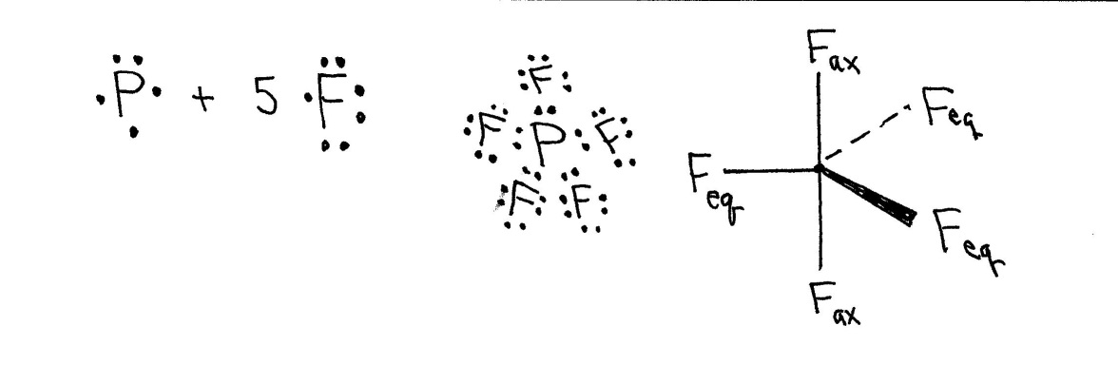
c) Predict the 3D geometry of PF₅ . Include bond angles in your description.
As shown above, the fluorine atoms define a trigonal bipyramid where ∠F_{ax}PF_{ax} = 180°, ∠F_{ax}PF_{eq} = 90°, and ∠F_{eq}PF_{eq} = 120°.
d) Give the hybridization of the P atom in PF₅ : ___dsp³_____________
2) This question deals with ketene, H₂CCO.
a) Draw its Lewis electron-dot structure.
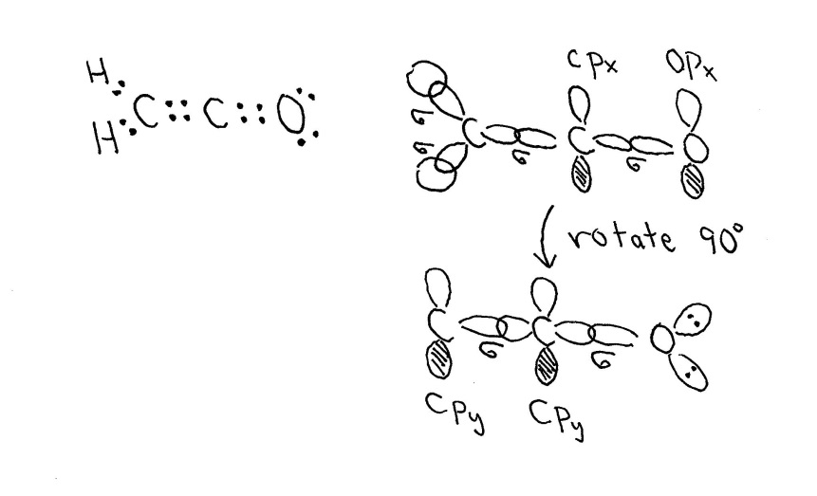

b) Predict the 3D geometry of ketene. Include estimates of bond angles in your description.
All atoms in the molecule lie in the same plane. ∠CCO = 180°, ∠HCO = ∠HCH = 120°,
c) Give a full description of the carbon,carbon and the carbon-oxygen bonds in ketene.
Refer to the diagram in the answer to part (a).
The C,C bond is a double bond with two components: a σ-type overlap of C sp² and C sp hybridized orbitals and a π-type overlap of C 2p unhybridized orbitals.
The C,O bond is a double bond with two components: a σ-type overlap of a C sp and O sp² hybridized orbitals and a π-type overlap of C and O 2p unhybridized orbitals.

