CHEMISTRY 132, FALL, 2013, SOLUTIONS TO PROBLEMS ON THE SECOND MIDTERM EXAMINATION
Part I (multiple choice section)
1) NH₃ has a CN of 4 so the N has a hybridization of sp³.
2) Based on 100 g of ferrocene, the mole ratio, C:H:Fe, is given by (64.56 g/12.01 g/mole):(5.42 g/1.008 g/mole):(30.02 g/55.845 g/mole) = 5.376: 5.377:0.5407. Dividing this ratio by 0.5407, one obtasins (5.376/0.5407):(5.377/0.5407)0.5407/0.5407) = 9.94:9.94:1 so the empirical formula of ferrocene is C₁₀H₁₀Fe.
3) From the Lewis electron-dot structure, N has a formal charge of zero. One of the oxygen atoms has a formal charge of -1, consistent with the net charge of the anion.
4) HCN has the structure H-C≡N: with one C,H single bond of σ symmetry and one C,N triple bond composed of a σ type overlap of sp hybridized orbitals and two π bonds. Therefore, a total of two σ bonds and two π bonds.
5) HBr are HNO₃ are strong acids and AgBr is an insoluble, solid product. The spectator ions, those not involved in the reaction are H⁺ and NO₃⁻.
6) HF(aq) is a weak acid. Given the high electronegativity of F, this is a surprise. The Second Law of Thermodynamics will provide an answer to this anomaly.
7) If C5H6 were the molecular formula, M would be (5)(12) + (6)(1) = 66 amu. This corresponds to the actual molecular mass so the molecular formula of cyclopentadiene is the same as its empirical formula of C₅H₆.
8) The coordination number around the N is 3 so a trigonal planar structure with ∠ClNO of approximately 120° is expected.
9) SF₄ with a coordination number bipyramid of 5 has a structure in the trigonal family. The heavy atoms define a see-saw structure.
10) Ammonia is a weak base and therefore a weak electrolyte in water.
11) Covalency as a bonding model involves the sharing of pairs, usually but not always pairs of electrons.
12) Adding up the atoms yields C₄H₈O₂. Note that in this compound of C, H, O an even number of H’s. All compounds composed exclusively of C, H, and O have an even number of H atoms.
13) Barium nitrate is soluble as the nitrate anion is a special anion.
14) In all chemical reactions, charge and mass are always conserved but molecules are not.
15) The stoichiometric coefficients should be integers. The balanced equation for the combustion reaction is 2 C₃H₈O(l) + 9 O₂(g) → 6 CO₂(g) + 8 H₂O(l).
16) n(Ca) = (10.0 g)/(40.078 g/mole) = 0.2495 mole, n(Ca(OH)₂) = n(Ca) = 0.2495 mole
M(Ca(OH)₂) = (1)(40.078 g/mole) +m (2)(15.9994 g/mole) + (2)(1.00789 g/mole) = 74.092 g/mole
M(100% yield, Ca(OH)₂) = M(Ca(OH)₂) n(Ca(OH)₂) = (74.092 g/mole)(0.2495 mole) = 18.49 g
%yield = [(observed mass)/(theoretical mass)] (100%) = [(5.00g)/(18.49 G)](100%) = 27.0%
17) n(HCl) = [con HCl]V(con HCl) = (12 M)(0.065 L) = 0.78 mole
[HCl, final] = n(HCl)/V(HCl) = (0.78 mole)/(0.15 L) = 5.2 M.
18) M(Asp) = (4)M(C) + (4)M(O) + (7)M(H) + (1)M(N) = 133 amu. Note that with an odd number of N atoms, the molecular mass rounded off the nearest integer is an odd number.
19) The reaction is :NH₃(aq) + HX(aq) → NH₄⁺(aq) + X⁻(aq) so an ammonium salt is produced.
20) HF(aq) is hydrofluoric acid, HF(s or g) is hydrogen fluoride
HOCl(aq) is hypochlorous acid. Recall OCl⁻ is the hypochlorite anion.
Hydrochloric acid is HCl(aq)
HClO₃(aq) is chloric acid. Recall ClO₃⁻ is the chlorate anion. (Compare sulfuric acid, H₂SO₄, and the the sulfate anion, SO₄₋₂.)
Chlorous acid is HClO₂.
H₂S(aq) is hydrosulfuric acid.
Part II
21) Sulfuric acid is a strong acid and sodium hydroxide is a strong base so the net ionic equation for the reaction is H⁺(aq) + OH-(aq) → H₂O(l).
n(H⁺) = 2[H₂SO₄]V(H₂SO₄ ) = (2)(0.3175 M)(0.01550 L) = 0.009843 mole [one mole of H₂SO₄ , a diprotic acid, yields two moles of H⁺(aq)]
From the titration reaction, n(OH⁻) = n(H⁺) = 0.009843 mole
m(NaOH) = n(OH⁻)M(NaOH) = (0.009843 mole)(39.9971 g/mole) = 0.3937 g
where M(NaOH) = (1)(22.989769) + (1)(15.9994) + (1)(1.00794) = 39.9971 g/mole.
22) Required data: M(CO₂) = (1)(12.0107) + (2)(15.9994) = 44.0095 g/mole
M(H₂O) = (2)(1.00794) + (1)(15.9994) = 18.01528 g/mole
From the combustion data,
n(C) = n(CO₂) (16.90 g)/(44.0095 g/mole) = 0.3840 mole
n(H) = (2)n(H2O) = (2)(3.458 g)/(18.01528 g/mole) = 0.3838 mole
n(C)/n(H) = (0.3840 mole)/(0.3838 mole) = 1:1 so the empirical formula is CH
If the molecule were CH is molecular mass would be (1)(12) + (1)(1) = 13 amu.
The actual molecular mass must be an integral multiple of 13 amu.
78 amu = (n)(13 amu) so n = 6 and the molecular formula of fulvene is C₆H₆.
23a) Iron(III) sulfide is insoluble so the first reaction is a precipitation reaction:
2 Fe⁺³(aq) + 3 S⁻²(aq) → Fe₂S₃(s)
23b) Hydroxide is a strong base and nitric acid is a strong acid. However, copper(II) hydroxide is an insoluble salt so the reaction of a combination of precipitation and acid-base reactions.
Cu(OH)₂ (s) + 2 H⁺(aq) → Cu⁺²(aq) + 2 H₂O(l)
24) To determine the limiting reagent, perform two calculations of the moles of product, first assuming oxygen is the limiting reagent and second assuming sulfur is the limiting reagent.
Needed data: M(O₂) = (2)(15.9994) = 32.00 g/mole, M(S) = 32.065 g/mole,
M(SO₂) = (1)( 32.065) + (2)( 15.9994) = 80.13 g/mole
n(O₂) = m(O₂)/M(O₂) = (12.0 g)/(32.00 g/mole) = 0.375 mole
n(S) = m(S)/M(S) = (8.50 g)/(32.065 g/mole) = 0.265 mole
stoichiometry: 2 S(g) + 3 O₂(g) → 2 SO₃(g)
a) assumption that oxygen is the limiting reagent
n(SO₃) = n(O₂)[(2 moles of SO₃)/(3 moles of O₂)] = (0.375)(2/3) = 0.250 mole
b) assumption that sulfur is the limiting reagent
n(SO₃) = n(S)[(2 moles of SO₃)/(2 moles of S)] = (0.265)(2/2) = 0.265 mole
0.265 > 0.250 so sulfur is in excess and oxygen is the limiting reagent and the stoichiometric amount of sulfur trioxide is determined from the moles of oxygen. As shown above, it is 0.250 mole. Finally m(SO₃) = n(SO3)M(SO₃) = (0.250 mole)(80.13 g/mole) = 20.0 g.

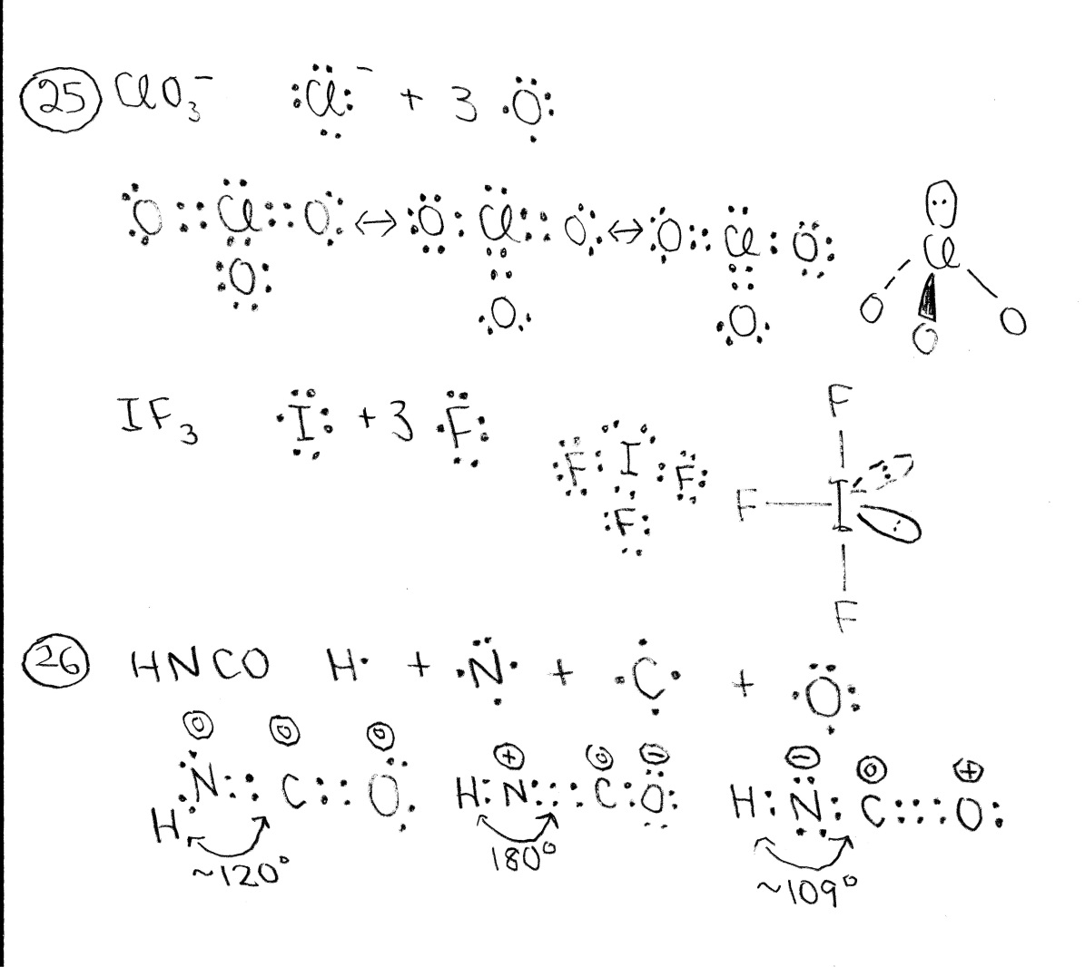
The chlorate structure uses extended valence on the chlorine to avoid formal charge. There are 3 resonance structures. The coordination number around the chlorine is 4 so the 3D structure belongs to the tetrahedron family. The heavy atoms define a triangular pyramid with the 3 oxygen atoms on the base and the chlorine at the apex.
Extended valence is required on the iodine atom. The coordination number around the iodine is 5 so the 3D structure belongs to the trigonal bipyramid structure. The heavy atoms define a “T” structure.
In the three Lewis-dot structures for HNCO, the formal charges are given enclosed in circles above each atom. The structure on the left is the most stable as it has zero formal charges on all atoms. The coordination number on the nitrogen is 3, leading to a trigonal planar structure and an estimate of 120° for ∠HNC. This prediction compares well with the structure derived from microwave spectroscopy.

