UNCA CHEMISTRY 132, FALL, 2013, PROFESSOR STEINMETZ’S SECTION
GROUP PROBLEMS, WEEK ONE: UNITS AND SIGNIFICANT DIGITS
1) A hydrologist reports that the volume of a lake is 34000 acre-feet. Calculate the volume of the lake in Liter and cubic meter. What is the mass of the water in the lake?
2) A geologist has a bag of marbles and wishes to measure their average density.
a) She has a supply of pure water at 298.15 K, a balance, and a graduated cylinder. Propose a protocol that she could use to determine the density.
b) Would the marbles’ density be useful to determine if they were made of granite?
c) Suggest another, more direct method of determining the density of the marbles.
3) Targets from two sessions at a rifle range are shown below. If you had the task of arming a patrol of counter-terrorists in Afghanistan, which firearm , the $400 AK 47 or the $1500 M16, would you purchase?
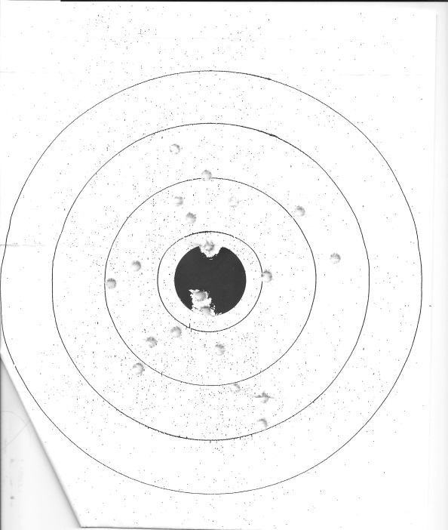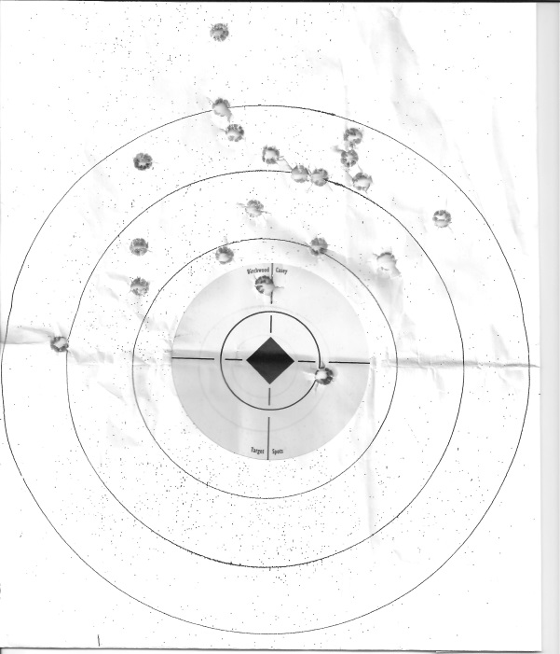
a) 20 rounds 0.233” Remington with a b) 20 rounds of 7.62 x 39 mm with a semi- semi-automatic M16 at 100 yards automatic AK47 at 50 yards

CHEM132_UNCA/group_problem_week1, 22 Aug 2013

